Alumni Relations and Job Placement Office

Date:______________

_____________

Name of Client: ______________________________________________________

Contact Number: ____________________________________

Requesting Office/ Department:___________________________

Purpose: __________________________________

Requested Data: ________________________________________

________________________________________

________________________________________

________________________________________

Requirement: (*check if accomplished)*

* Letter of Request

Date Requested: ________________

Date Released: ________________

------------------------------------------------------------------------------------------

**Claim Stub**

Alumni Data

Date Requested: ________________ Date Released: ________________

ARJPO Staff

 -----------------------------------------------------------------------------------------

**Claim Stub**

Alumni Data

Date Requested: ________________ Date Released: ________________

ARJPO Staff

*MPSPC-ARJ-F-004/02/September 4, 2023*

*Page 1 of 1*

**ISSUANCE OF ALUMNI DATA**

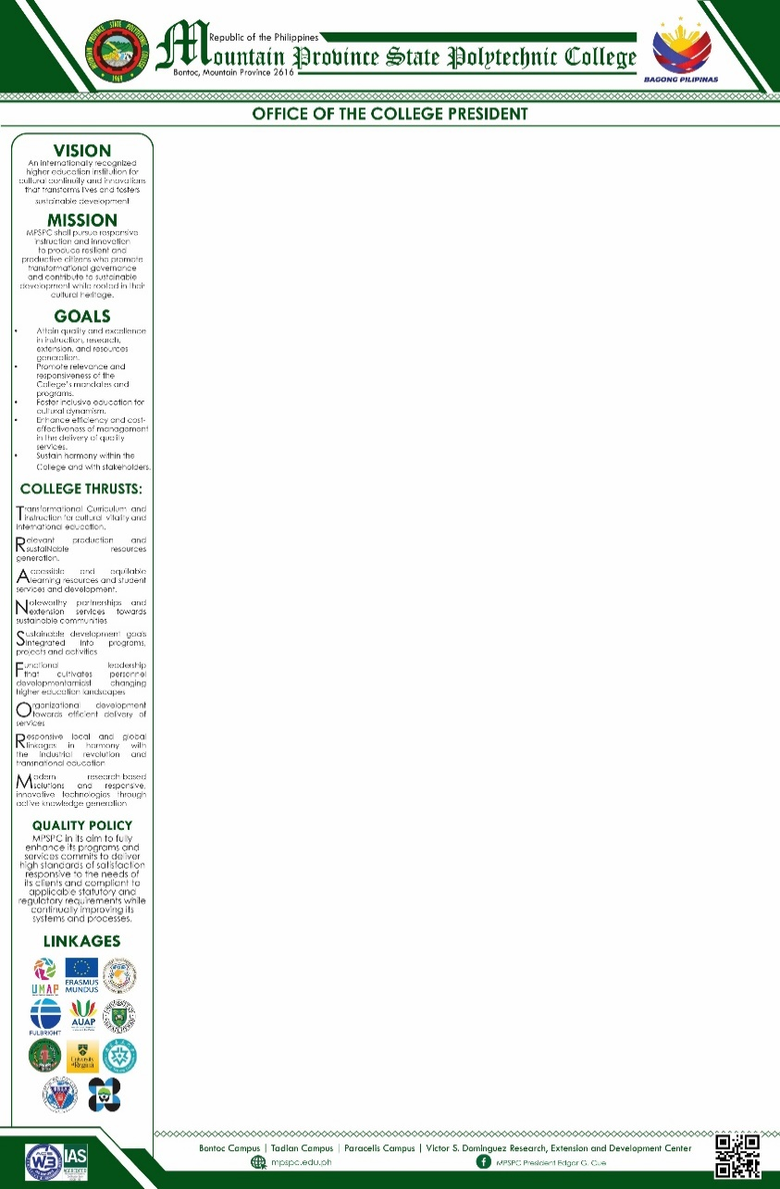

Alumni Relations and Job Placement Office

Date:______________

_____________

Name of Client: ______________________________________________________

Contact Number: ____________________________________

Requesting Office/ Department:___________________________

Purpose: __________________________________

Requested Data: ________________________________________

________________________________________

________________________________________

________________________________________

Requirement: (*check if accomplished)*

* Letter of Request

Date Requested: ________________

Date Released: ________________

------------------------------------------------------------------------------------------

**Claim Stub**

Alumni Data

Date Requested: ________________ Date Released: ________________

ARJPO Staff

 -----------------------------------------------------------------------------------------

**Claim Stub**

Alumni Data

Date Requested: ________________ Date Released: ________________

ARJPO Staff

*MPSPC-ARJ-F-004/02/September 4, 2023*

*Page 1 of 1*

**ISSUANCE OF ALUMNI DATA**



Republic of the Philippines

Mountain Province State Polytechnic College

Bontoc, Mountain Province

Alumni Relations and Job Placement Office

Date:______________

_____________

Name of Client: ______________________________________________________

Contact Number: ____________________________________

Requesting Office/ Department:___________________________

Purpose: __________________________________

Requested Data: ________________________________________

________________________________________

________________________________________

________________________________________

Requirement: (*check if accomplished)*

* Letter of Request

Date Requested: ________________

Date Released: ________________

------------------------------------------------------------------------------------------

**Claim Stub**

Alumni Data

Date Requested: ________________ Date Released: ________________

ARJPO Staff

 -----------------------------------------------------------------------------------------

**Claim Stub**

Alumni Data

Date Requested: ________________ Date Released: ________________

ARJPO Staff

*MPSPC-ARJ-F-004/02/September 4, 2023*

*Page 1 of 1*

**ISSUANCE OF ALUMNI DATA**



Alumni Relations and Job Placement Office

Date:______________

_____________

Name of Client: ______________________________________________________

Contact Number: ____________________________________

Requesting Office/ Department:___________________________

Purpose: __________________________________

Requested Data: ________________________________________

________________________________________

________________________________________

________________________________________

Requirement: (*check if accomplished)*

* Letter of Request

Date Requested: ________________

Date Released: ________________

------------------------------------------------------------------------------------------

**Claim Stub**

Alumni Data

Date Requested: ________________ Date Released: ________________

ARJPO Staff

 -----------------------------------------------------------------------------------------

**Claim Stub**

Alumni Data

Date Requested: ________________ Date Released: ________________

ARJPO Staff

*MPSPC-ARJ-F-004/02/September 4, 2023*

*Page 1 of 1*

**ISSUANCE OF ALUMNI DATA**

