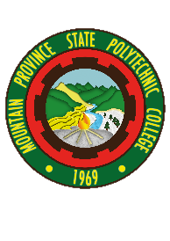

Republic of the PhilippinesMountain Province State Polytechnic CollegeBontoc, Mountain Province

**Certificate of Accreditation**

is awarded to



for having complied with all the requirements for accreditation of student organizations and by virtue hereof is recognized by the College as an official organization to enact its mandated functions.

The organization and its officers shall commit to observe the provisions in their Constitution and By-Laws and the existing rules and regulations of the College and the National Government with respect to their activities, projects and programs.

This Certificate of Accreditation is valid for the School Year 2019-2020 unless sooner revoked or suspended by the College.

Issued at MPSPC Bontoc, Mountain Province, Philippines this ­­­­­______ day of ______________________.

**RUDY T. PAPSA-AO, JR. JONI L. PAGANDIYAN LIBERTY A. TUDLONG CHRISTIE LYNNE C. CODOD**

*Student Organizations SSDO Dean OSA Executive Director Executive Dean*

*Coordinator*

***MPSPC-SOO-F-004/00/November 24, 2020***