STUDENT SERVICES AND DEVELOPMENT OFFICE

**Checklist of Requirements for Off-Campus Activity**

Department/ Unit:

Requirements: (check if accomplished)

→ Emergency Preparedness Plan

→ Duly notarized Parent’s Waiver/ Consent

→ Duly Notarized Students’ Waiver

→ Approved Communication from the Office of the President/Activity Design

→ Authority to travel

→ Itinerary of Travel

→ Medical Certificate duly signed by the School’s Physician

→ First Aid Training Certificate of the Accompanying personnel/ instructor

→ Duly Approved Vehicle Reservation Form (GSO)

Additional Requirements: (if vehicles are hired from the private entities)

→ Certificate of Roadworthiness from the owner

→ Certification from LTO

→ Photocopy of Updated Driver’s License

*MPSPC-SSD-F-009/02/September 4, 2023*

*Page 1 of 1*

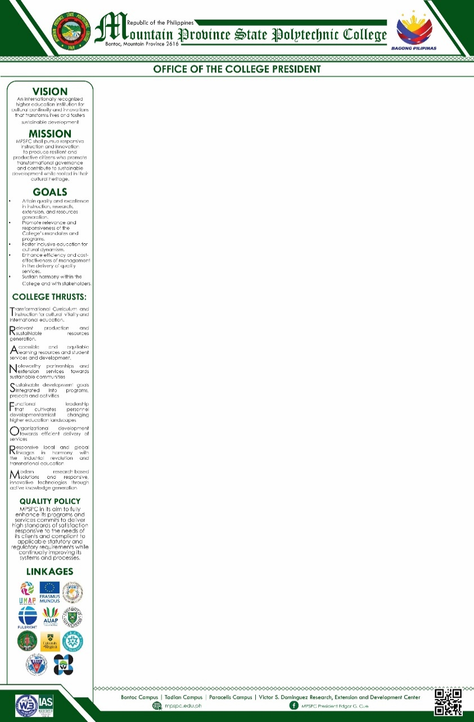

STUDENT SERVICES AND DEVELOPMENT OFFICE

**Checklist of Requirements for Off-Campus Activity**

Department/ Unit:

Requirements: (check if accomplished)

→ Emergency Preparedness Plan

→ Duly notarized Parent’s Waiver/ Consent

→ Duly Notarized Students’ Waiver

→ Approved Communication from the Office of the President/Activity Design

→ Authority to travel

→ Itinerary of Travel

→ Medical Certificate duly signed by the School’s Physician

→ First Aid Training Certificate of the Accompanying personnel/ instructor

→ Duly Approved Vehicle Reservation Form (GSO)

Additional Requirements: (if vehicles are hired from the private entities)

→ Certificate of Roadworthiness from the owner

→ Certification from LTO

→ Photocopy of Updated Driver’s License

*MPSPC-SSD-F-009/02/September 4, 2023*

*Page 1 of 1*



STUDENT SERVICES AND DEVELOPMENT OFFICE

**Checklist of Requirements for Off-Campus Activity**

Department/ Unit:

Requirements: (check if accomplished)

→ Emergency Preparedness Plan

→ Duly notarized Parent’s Waiver/ Consent

→ Duly Notarized Students’ Waiver

→ Approved Communication from the Office of the President/Activity Design

→ Authority to travel

→ Itinerary of Travel

→ Medical Certificate duly signed by the School’s Physician

→ First Aid Training Certificate of the Accompanying personnel/ instructor

→ Duly Approved Vehicle Reservation Form (GSO)

Additional Requirements: (if vehicles are hired from the private entities)

→ Certificate of Roadworthiness from the owner

→ Certification from LTO

→ Photocopy of Updated Driver’s License

*MPSPC-SSD-F-009/02/September 4, 2023*

*Page 1 of 1*



STUDENT SERVICES AND DEVELOPMENT OFFICE

**Checklist of Requirements for Off-Campus Activity**

Department/ Unit:

Requirements: (check if accomplished)

→ Emergency Preparedness Plan

→ Duly notarized Parent’s Waiver/ Consent

→ Duly Notarized Students’ Waiver

→ Approved Communication from the Office of the President/Activity Design

→ Authority to travel

→ Itinerary of Travel

→ Medical Certificate duly signed by the School’s Physician

→ First Aid Training Certificate of the Accompanying personnel/ instructor

→ Duly Approved Vehicle Reservation Form (GSO)

Additional Requirements: (if vehicles are hired from the private entities)

→ Certificate of Roadworthiness from the owner

→ Certification from LTO

→ Photocopy of Updated Driver’s License

*MPSPC-SSD-F-009/02/September 4, 2023*

*Page 1 of 1*

